AZURE KEY VAULT

- Azure Key Vault is a cloud service from Microsoft Azure used to securely store and manage sensitive information like :
API keys, Passwords, Certificates, Encryption keys, Connection strings
- Instead of hardcoding secrets in your application, you store them in Key Vault and fetch them securely at runtime.

- How it is used
- Typical usage flow:
- Store secrets in Key Vault (manually, CLI, or CI/CD pipeline)
- Give your application access permissions using Azure Active Directory (AAD)
- Application retrieves secrets securely using SDK / REST API
- Secrets are used at runtime (DB connection, API calls, etc.)
- Example :
- App running in Azure VM → fetches DB password from Key Vault → connects to database

- Why it is used
- Key Vault solves major security problems:
- ❌ Avoids hardcoding secrets in code
- ❌ Prevents exposure in GitHub repositories
- ❌ Centralizes secret management
- ❌ Enables rotation of keys without changing code
- ❌ Improves compliance (PCI-DSS, ISO, etc.)

- Advantages and Disadvantages

👍 Pros or Advantages | 👎 Cons or Disadvantages
Strong security with hardware-backed encryption (HSM support) | Slight learning curve (RBAC + policies + identity setup)
Centralized secret management | Can add latency (secret fetch at runtime)
Fine-grained access control using Azure AD | Cost increases with advanced features (HSM, high operations)
Easy integration with Azure services (VMs, App Service, AKS) | Dependency on Azure ecosystem (less portable)
Supports automatic key rotation | Misconfiguration of access policies can cause outages
Audit logging via Azure Monitor

- Similar services in AWS equivalent services
- AWS does not have a single exact match, but equivalent functionality is split across services:

1. 🔐 AWS Secrets Manager | 2. 🔑 AWS Key Management Service (KMS)
AWS Secrets Manager | AWS Key Management Service
Closest equivalent to Azure Key Vault (for passwords, API keys, DB credentials) | Equivalent for encryption key management
Stores secrets securely | Manages encryption keys (not general secrets)
Built-in automatic rotation (RDS, etc.) | Used for encrypting S3, EBS, RDS, etc.
Tight integration with IAM | Highly integrated with AWS services

- Quick comparison
Feature | Azure Key Vault | AWS Equivalent
Secrets storage | Yes | Secrets Manager
Key management | Yes | KMS
Certificate management | Yes | Partial (ACM)
Access control | Azure AD | IAM
Rotation support | Yes | Yes (Secrets Manager)

- Simple summary
- Azure Key Vault = secure vault for secrets + keys + certificates
- AWS splits this into:
  - Secrets → Secrets Manager
  - Encryption keys → KMS

Azure Key Vault :

- What is it & How do use it
Why should we use it
Keys vs secret

Azure key vault is used to secure store – keys, secrets & certificates

Secret = connection string to connect to db

We will store secrets in app seetings.json or web config
It’s a read or connection string

But if we use key vault web app will directly use and fetch connection string from key vault

It is encrypted and can not be seen directly

Key vault is restricted

Key = [ same key to encrypt disk ]
Key used for cryptographic encryption
This key is stored in same secured file or db

If user delete the key
Then server link is gone

If there are 2 services
Storage account and key
We will provide required permissions to access the key

There is no permission to access user to access key
Storage account is accessed key in encrypted firewall

- Create azure key vault and add key and secret key

We will create our first “ key vault “ in portal

We will assign the role to ourself
( so we can add or edit – keys and secrets )

We will add ‘secret’ in key vault

We will generate ‘key’ in key vault

Lets do practical

Create Key vault in azure
- In azure in search bar , search key vault

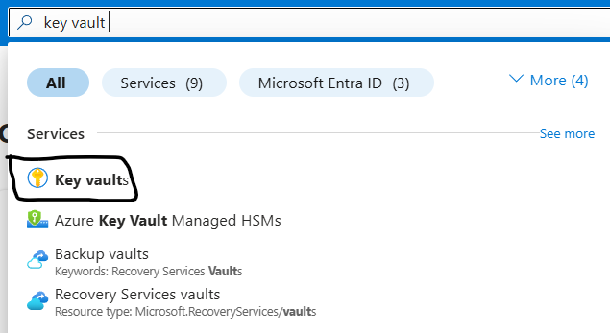

- Now this is azure key vault service

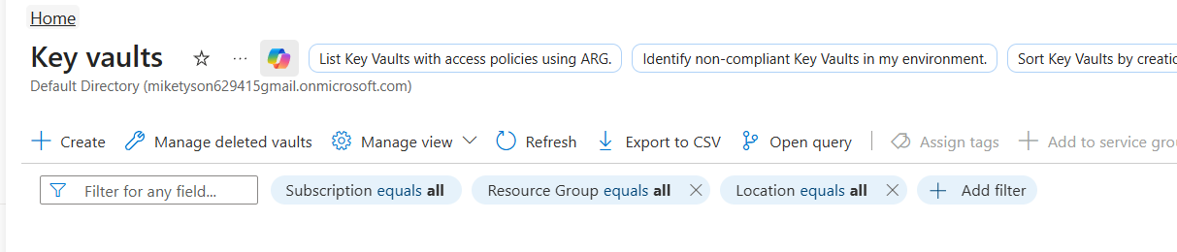

- Create a key vault
  - Resource Group : select your resource group
  - Key vault Name : provide any unique name
  - Region : korea central
  - Pricing : standard

  - Soft delete will be default enabled with 90 days
  - Reduce it to 7 days
- Access configuration leave it
- Networking : all networks

If selected networks created only particular vnets can be able to access key vault rest no access
We can select existing key vault or we can create one vnet

- Create azure key vault
- It takes just 10 to 20 seconds

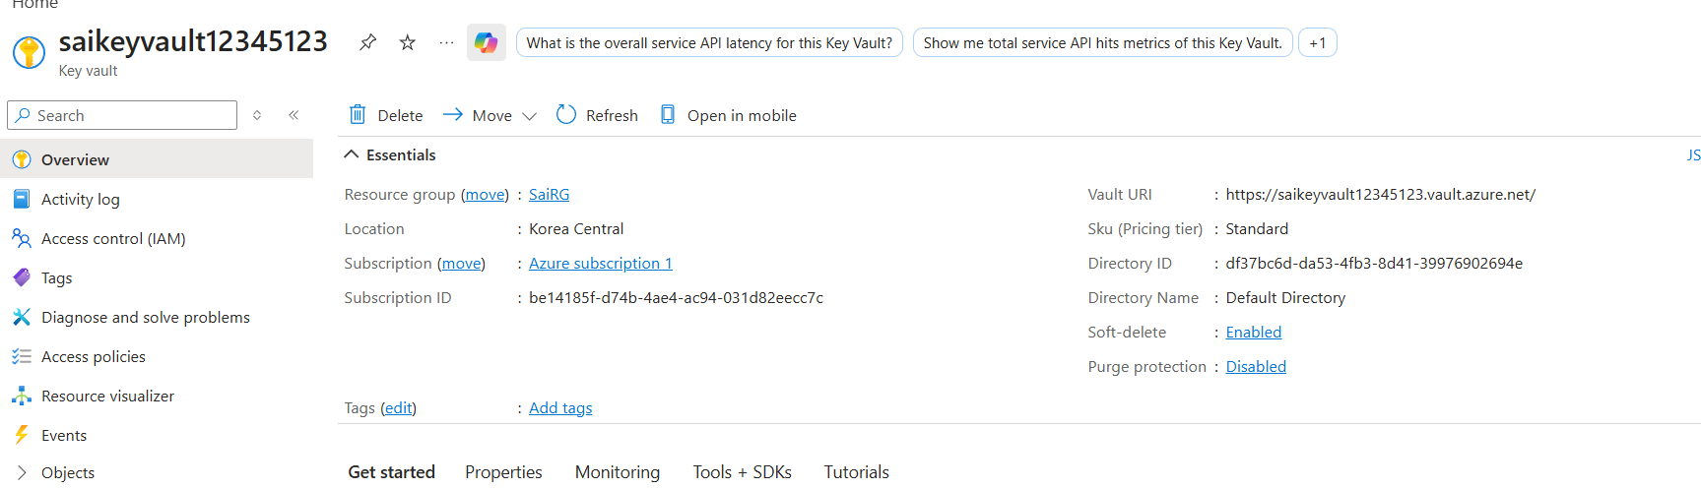

- Now we got vault id also
- Under objects we can find keys, secrets, and certificates
- Now select secrets and try to create a secret

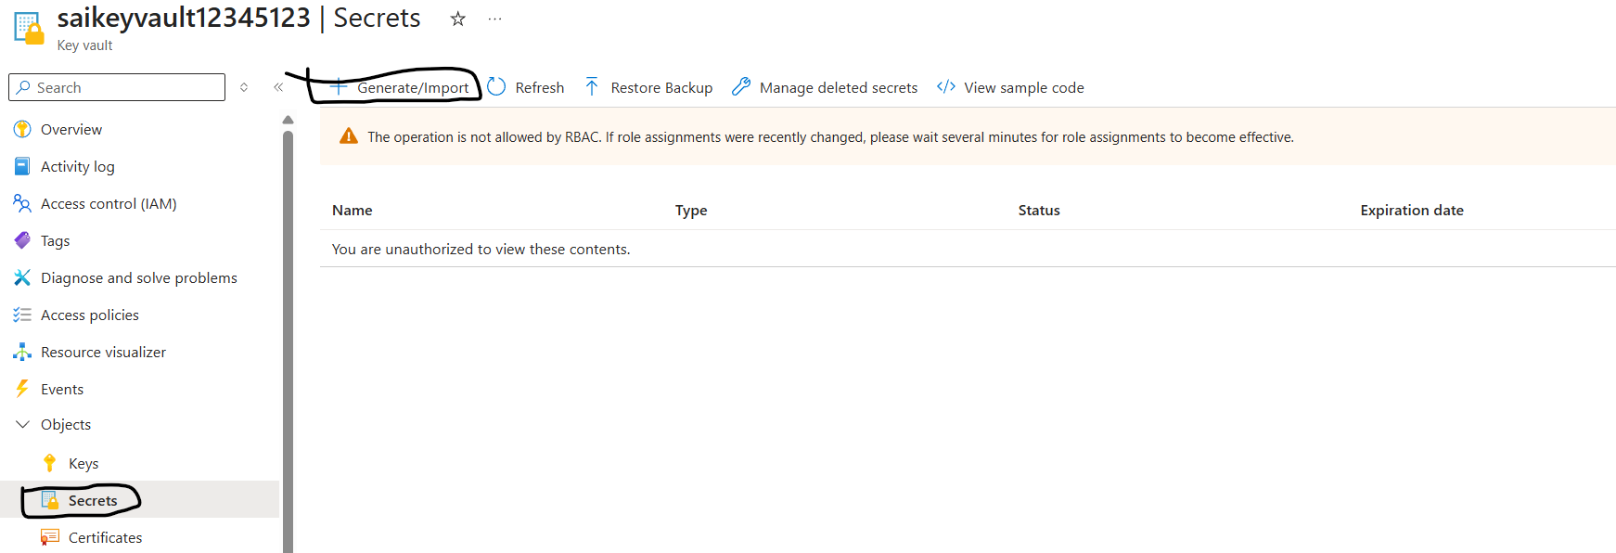

- Now once we try to create secret
- It says not allowed by rbac

- Open IAM in subscription
- Add role assignment
- In job functional roles : search for secret
- Key Vault Secrets Officer select it
- Next
- Now add selected members and add your registered member

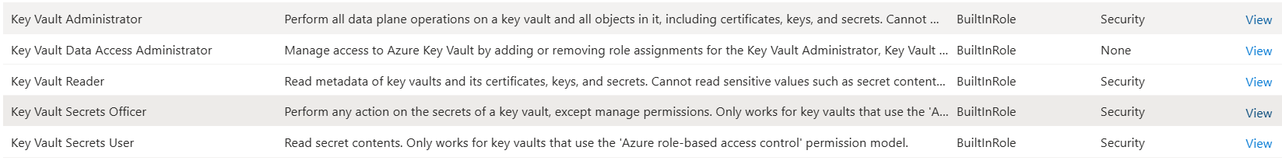

- Review and assign -> review and assign
- Now we can add in key vault secret
- But we can not add in keys

- Add role as key vault crypto officer
- Now try to create again
- Now key can be created

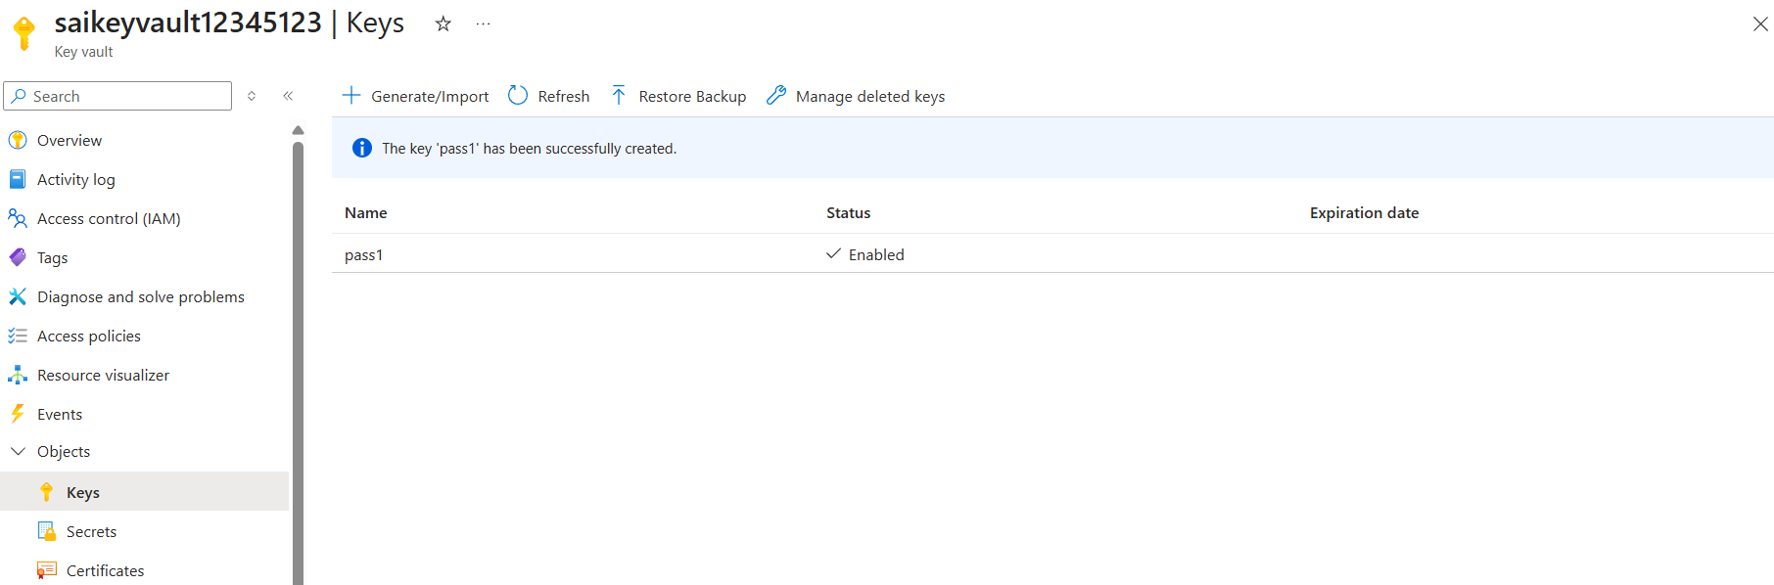

- Done now we can able to add keys

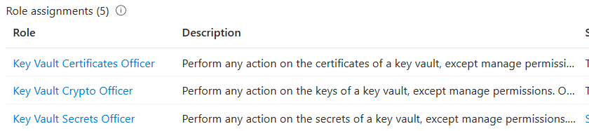

- Key vault secret officer for secrets
- Key vault crypto officer for keys
- Key vault certificate officer for certificates

- Key Vault Administrator for all 3 common

- Customer managed key for azure storage encryption

- Demo – where we will use key from key vault to encrypt storage account
- We will use managed identity
- To encrypt our storage account we are fetching the key from azure
- So our storage account should have the required permission to access the key from this key vault
- For this storage account we can provide using managed identity

- Key = cryptographic operations
- It is used for encryption
- Eg : we can encrypt storage account using key
- And we can fetch this key from azure key vault

- While creating storage account

  - Resource group : select yours
  - Storage account name : small letters, numbers and no space
must be unique
  - Region : any
  - Preferred storage type : blob storage
  - Performance : standard
  - Redundancy : LRS
  - Disable all soft delete or unticks
  - In security : enable Allow enabling anonymous access on individual containers
  - Encryption type : MMK
  - Review and create

- We have created 1 key for storage account
- Open storage account, in left bar
  - Under security and networking
  - Select encryption, it would be default MMK
  - Now select CMK

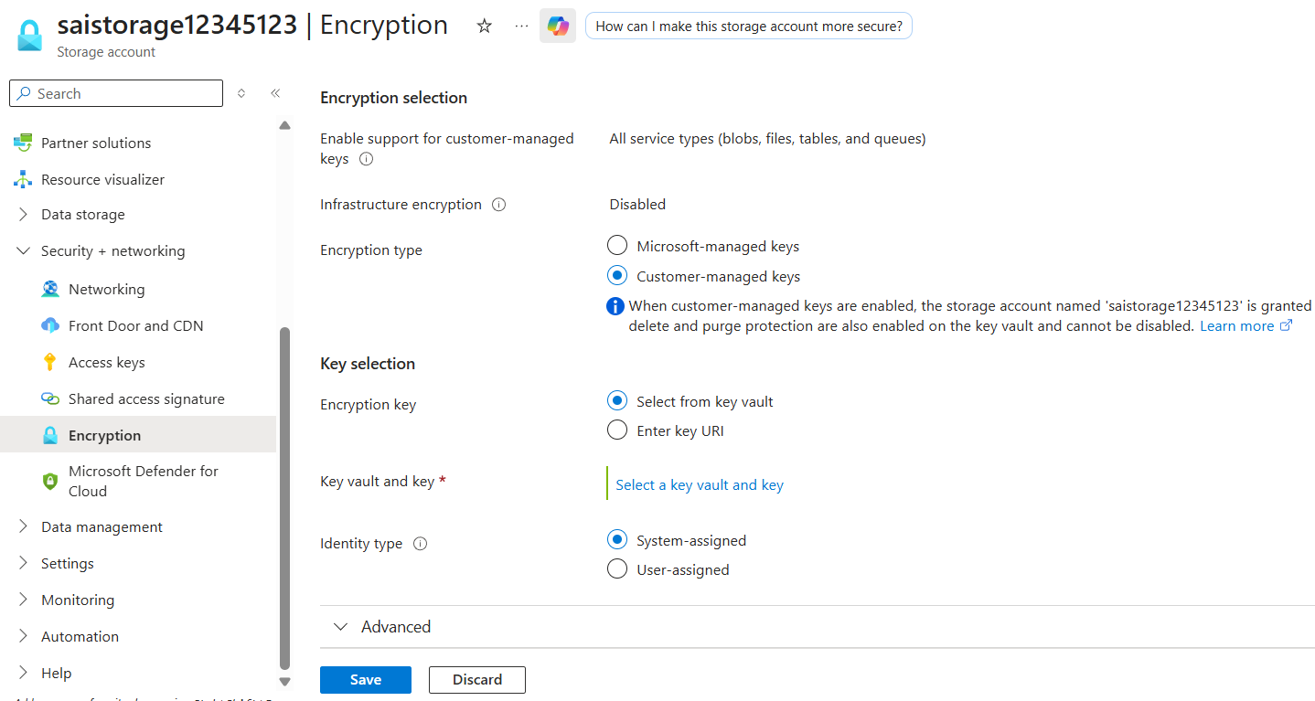

  - Click on select a key vault and key
    - Select Subscription
    - Key store type : key vault
    - Key vault : select your key vault
    - Key : select your key
    - Now save this
  - Save this

- Now you will face error as permission

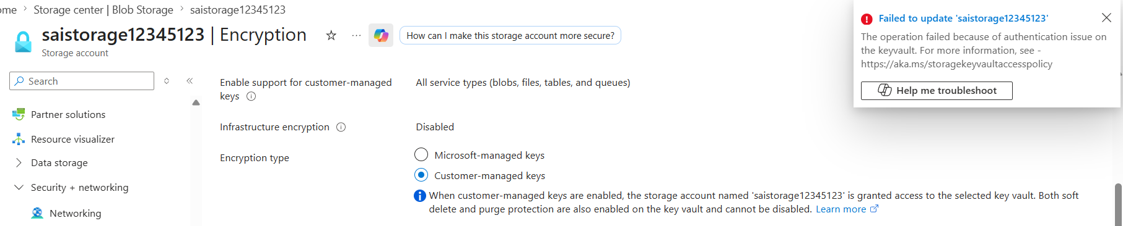

- Open azure key vault
- Open IAM
- Click on add -> add role assignment
- Job function roles -> search as crypto
- Select Key Vault Crypto Officer
- Next
- Assign access to : Managed identity
  - Select subscription type : subscription 1
  - Managed Identity : storage account
  - Select your storage account id

- Managed identity means providing permission to service or service account

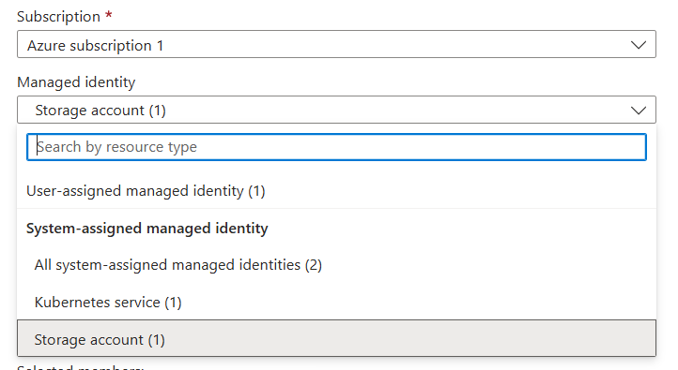

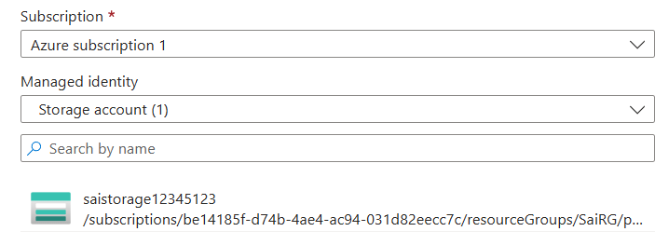

- After selecting and click on add member
- Review and assign
- Review and assign

- Now from storage account again try to add key from key vault
- Storage account -> security and networking
  - Encryption
  - Encryption type : customer managed keys
  - Encryption key : Select from key vault
  - Key vault and key : click on a key vault and key
    - Subscription : select it
    - Key store type : kay vault
    - Kay vault : select your key vault
    - Key : select the key
    - Save
  - Save

- Azure Key Vault Secret To Protect .Net App Connection String

Secret = Connection string in project

Demo = asp .net core web project we will first connection string from app-settings
Then we will modify our code to fetch connection a string from key vault

In appsettings

“connectionstrings”: {
“sqlConnectionString”
}

From controller.cs

Private readonly IConfiguration _configuration;

If using in vs code manage 2 packages
Azure.Extensions.AspNetCore.Configuration.Secrets
Azure.Identity

In appsettings add this line

“connectionstrings”: {
“sqlConnectionString”
}
“KeyVaultName” : “ourfirstkeyvault2”

In vscode the account which you are using should have enough permission to access key vault

- KEY ROTATION VS SECRET ROTATION |
KEY EXPIRY VS SECRET EXPIRY

- Key vs Secret
- Key = Cryptographic operation
eg – encrypt storage account using key
- Secret = connection string to connect to storage account OR SQL Database

- From storage account -> Security and networking
- Encryption
- Current Key : https://saikeyvault12345123.vault.azure.net/keys/pass1
  - Here pass1 is key name is calling from
  - Account saikeyvault12345123 from key vault service

- Key expiry vs secret expiry
- Key expiry = Expiry key can’t be used for encryption
- But older version of key which is not expired can used for encryption

- Now lets take example for understanding :
- Open azure key vault account -> Object -> key

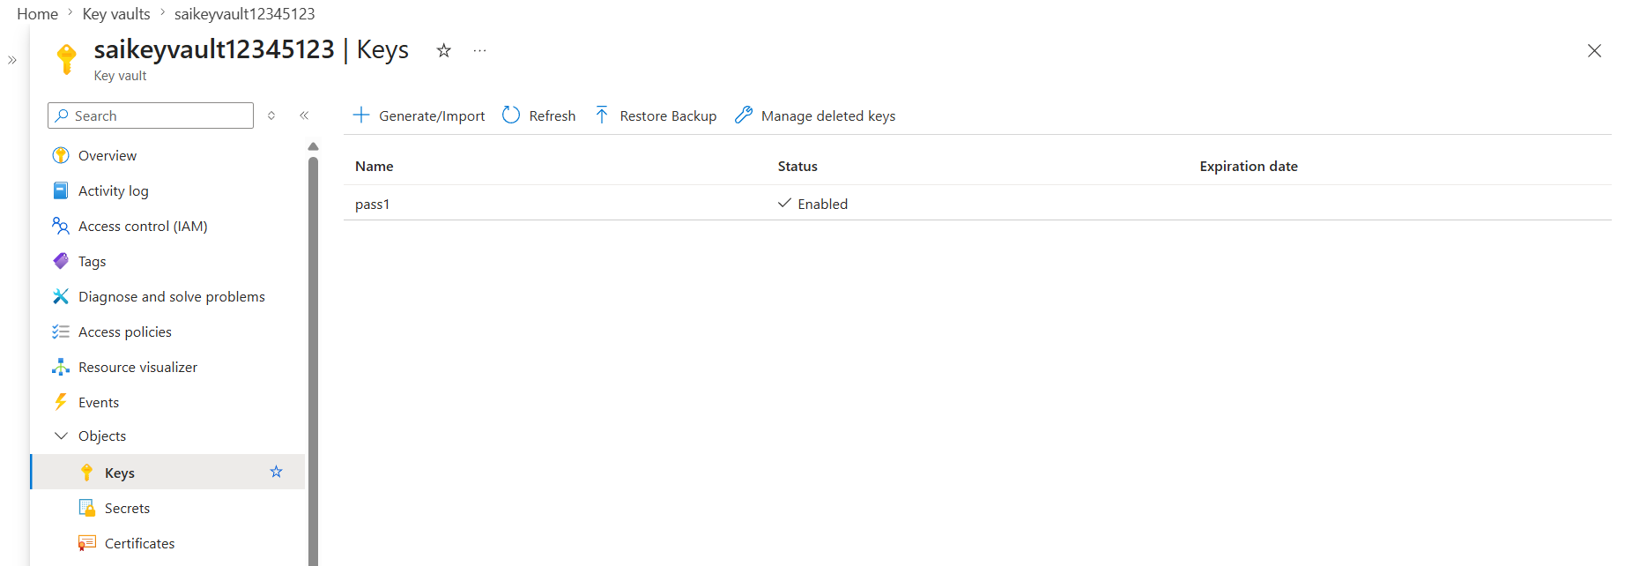

- Now select your key

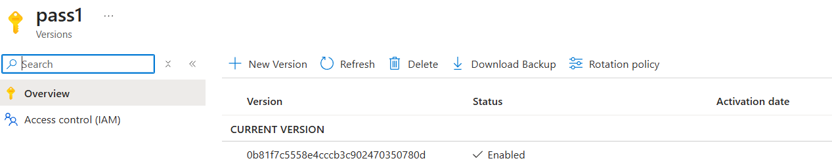

- Now observer that from key vault -> object -> key -> select key
the key version from key vault and
- Now from storage account -> security + networking -> encryption ->

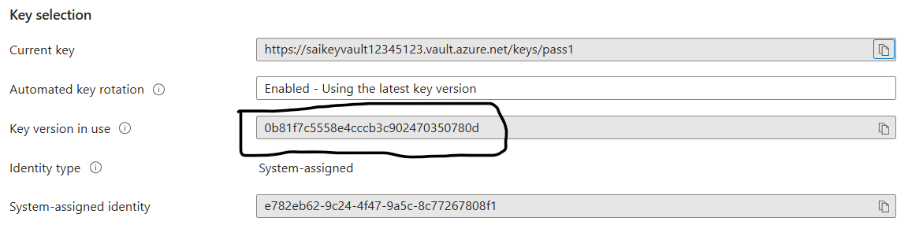

- Now version of key from key vault and storage account, encryption both are same

- Now lets change the version
- Open key vault key vault -> object -> key -> select key
- Select new version :
- Now you can check in key version -> under settings
- We can observe activation and expiry date

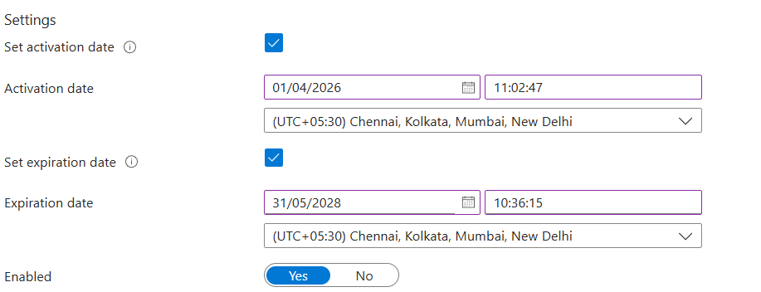

- Now we got 2 version
- 1 is new version and one is old version
- New version is expired but in storage account it still uses old version only
- Lets check once

- Open storage account -> security + networking -> encryption ->
- Check the key version in use, even after refresh it wont change

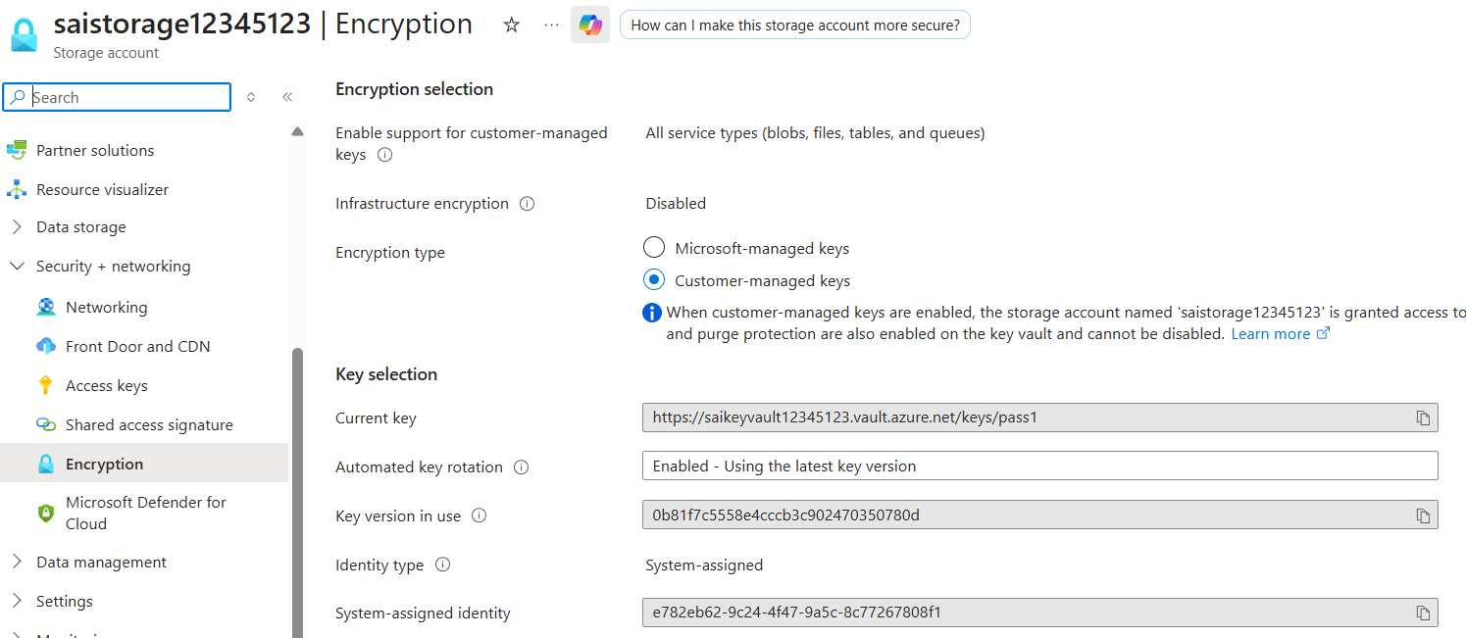

- In storage account it uses old version only
- In storage account we can observer one option like Automated Key rotation
When enabled, automatically updates the customer-managed key to the latest key version.
- Means after 24 hours it checks with expiry date and automatically changes version if needed

- Secret Expiry : Expired secret i.e connection string still works
- i.e we can still fetch expired in our project
- if secret is expired also still we can use connection string
- just for good practice

- What it means by ‘Rotation’
i.e Creating new Version
- Rotation is simply creating new version
- Key rotation and secret rotation

- Key Rotation vs Secret Rotation
- Create new version of key before current version expires
it takes at least 24 hours in
- Key rotation = simple = just have overlapping of expiry dates of 2 versions of key

- In key vault one key is created, it about to expire in 24 hours
- If one more key is created with more expired time
- Until the old key expires storage account uses old key
- And then it changes to new key in 24 hours

- But Secret Rotation is not straight forward
- If we create new version in secret
- We can not create new version in secret directly
- If this is happen our application goes down,
- We need to create connection string in app or database the same connection string should update in key vault secret.

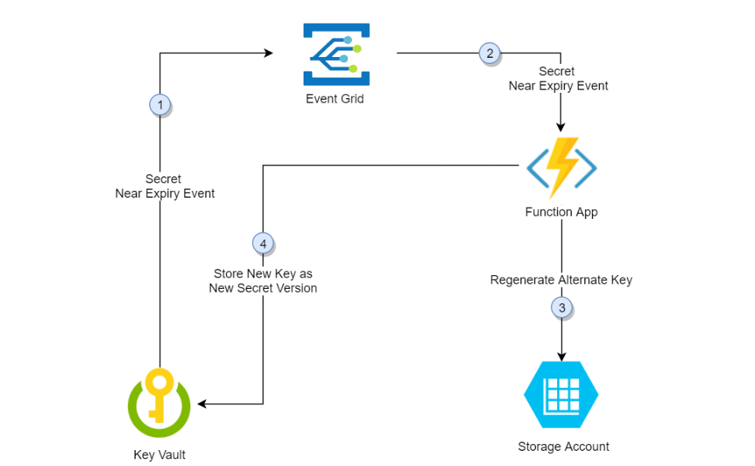

- Process work flow.
- Before secret gets expired,
- Our event grid will be triggered,
- Its call azure function as secret is near to expiry,
- Azure function will generate new secret or new connection,
- For sql database or storage account and it will update,
- It will now update in sql db or storage account,
- That new key or new secret it will update as new version

- Official Link for documentation : https://learn.microsoft.com/en-us/azure/key-vault/secrets/tutorial-rotation-dual?tabs=azure-cli

- SOFT DELETE AND PURGE PROTECTION
- Understanding these concepts & importance
- Quick Demo
- Why enabling ‘Soft Delete’ & ‘Purge Protection’ is important

- Soft Delete = Soft deleted
i.e not permanently deleted

- We should always enable soft delete, if key or secret deleted by mistake,
If soft delete is not enabled that means we cannot recover the key and secret.

- Purge protection = whether soft deleted keys/secrets,
we can delete them permanently

- When purge protection is enabled that soft deleted key or secret can not be permanently deleted for some period of time
- If purge protection key is disabled, the soft deleted key or secret can be deleted permanently.

- Quick Demo
- By default soft delete is enabled while creating key vault
- If created Key vault using CLI / Power shell or Rest API. We can disable soft delete :
- The ability to turn off soft delete via the Azure Portal has been deprecated. You can create a new key vault with soft delete off for a limited time using CLI / PowerShell / REST API. The ability to create a key vault with soft delete disabled will be fully deprecated by the end of the year.

- If key vault created using GUI then its default enabled.

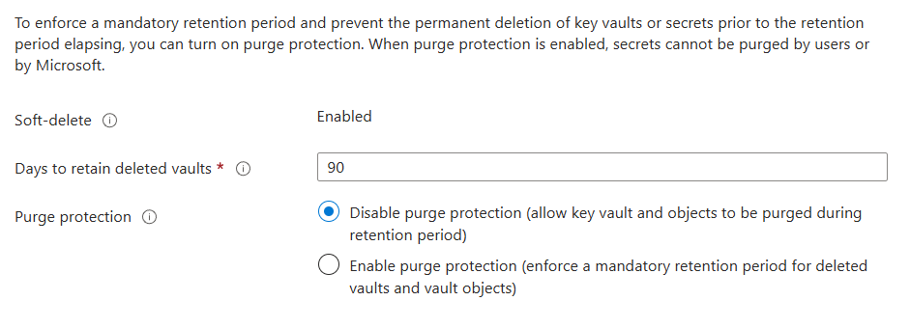

- Purge = permanent delete

- Disable purge protection : (allow key vault and objects to be purged during retention period)
- Enable purge protection : (enforce a mandatory retention period for deleted vaults and vault objects)
- If purge protection is enabled, soft deleted keys or secrets can not be deleted until its retension periods

- If any key is deleted would come to soft deleted
- If purge protection is disabled then, we can permanently delete those soft deleted keys or secrets.

- Now soft delete and purge are enabled

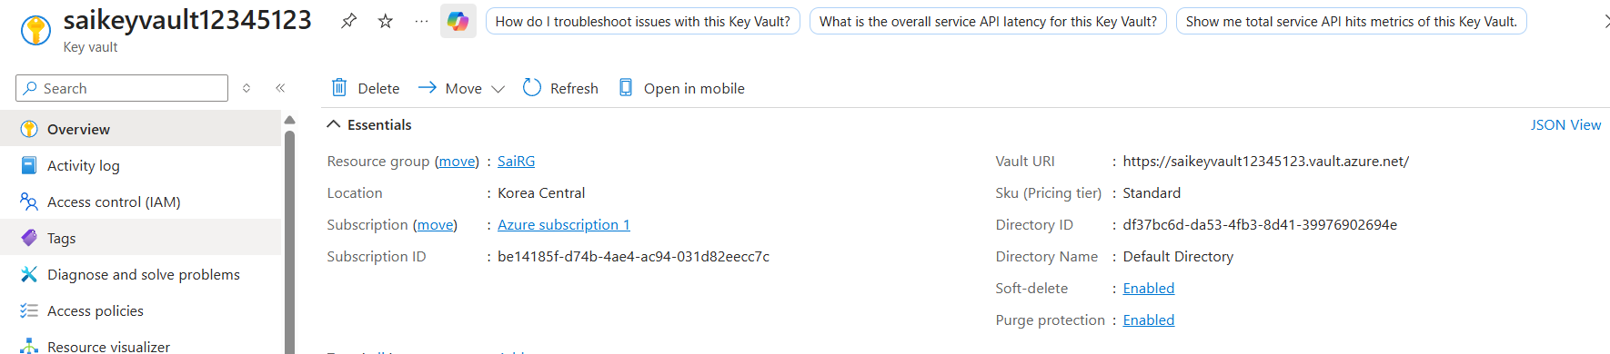

- You can observe Soft delete and purge protection is enabled
- Open azure -> key vault -> Objects -> secrets

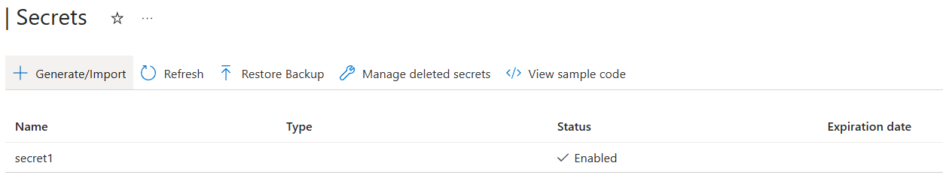

- Now we are having one secret lets delete it try again

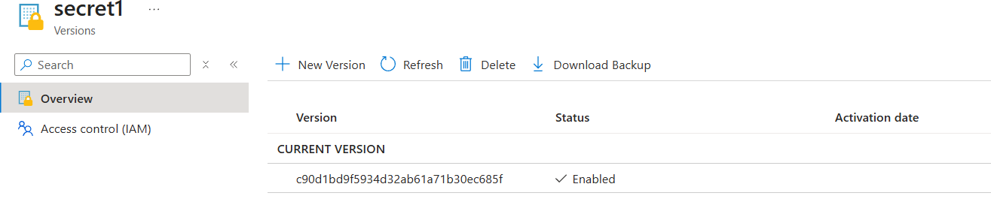

- Now we deleted it and we can observe that deleted pop up reflected

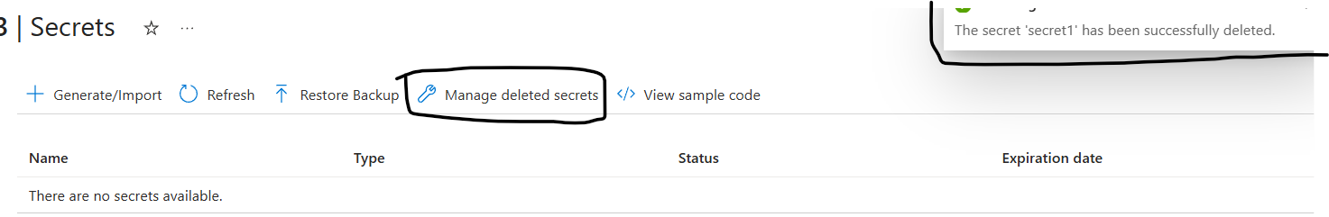

- Now we can observe managed deleted secrets
- Click on to check

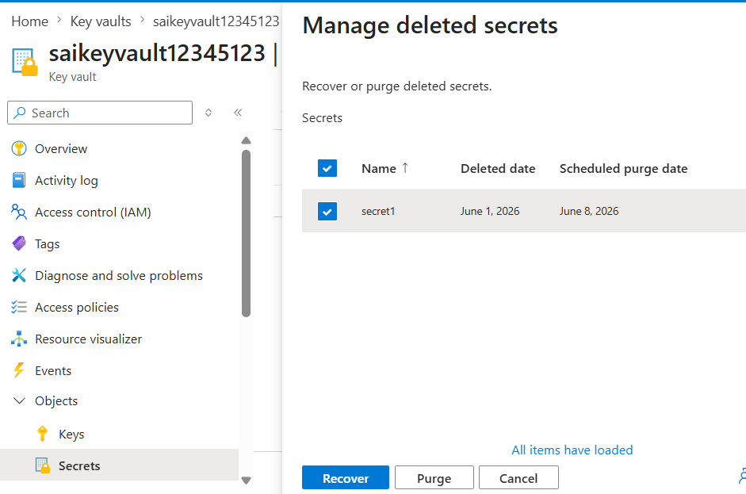

- Now we can see 2 options as Recover, and purge
- Click on recover

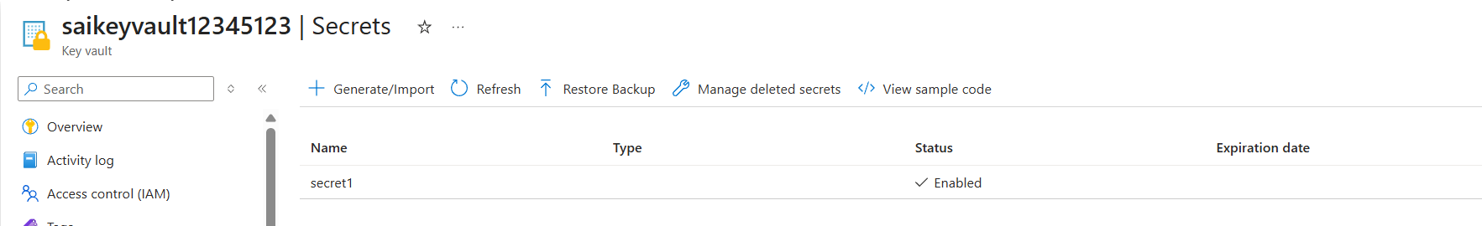

- We got it back
- Now try to delete and purge

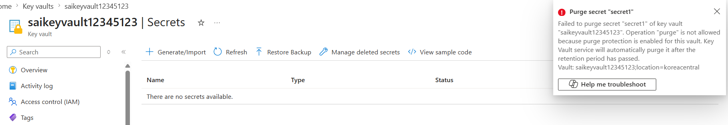

- We can not delete the secret from managed deleted instance but we can recover.

- Lets try for KEY now

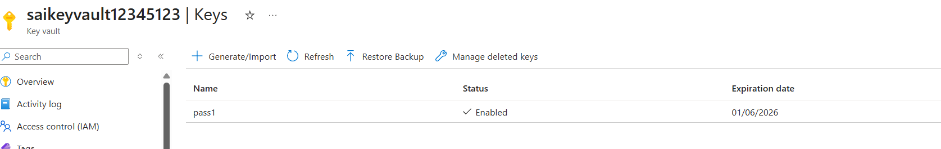

- Now select the key

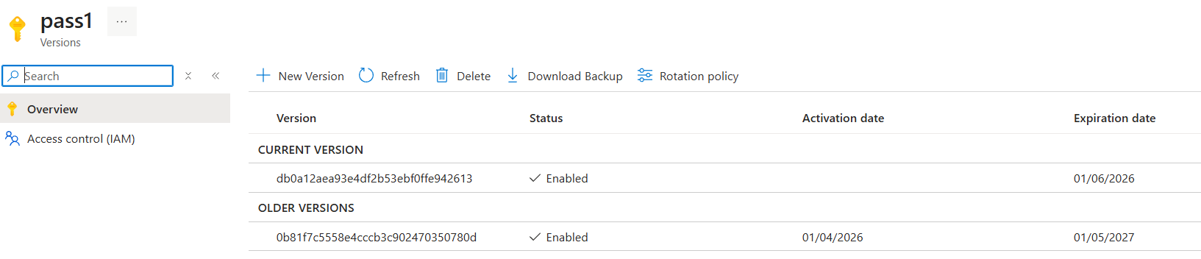

- Now delete the key

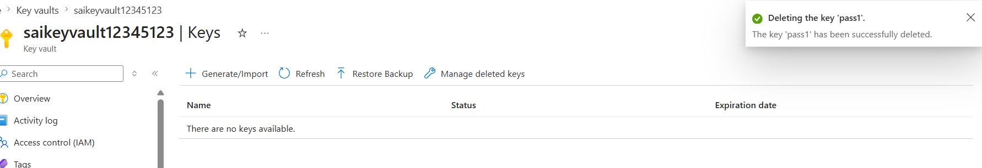

- Now click on managed deleted keys

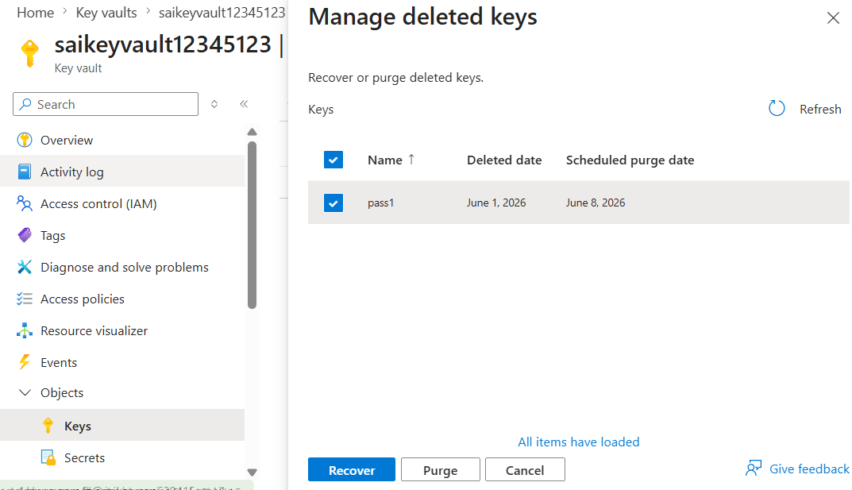

- Select key and click on purge to delete

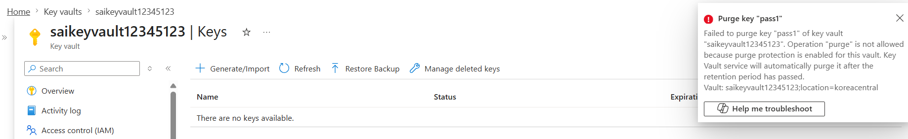

- We can see that we can not delete the key as it is enabled purge

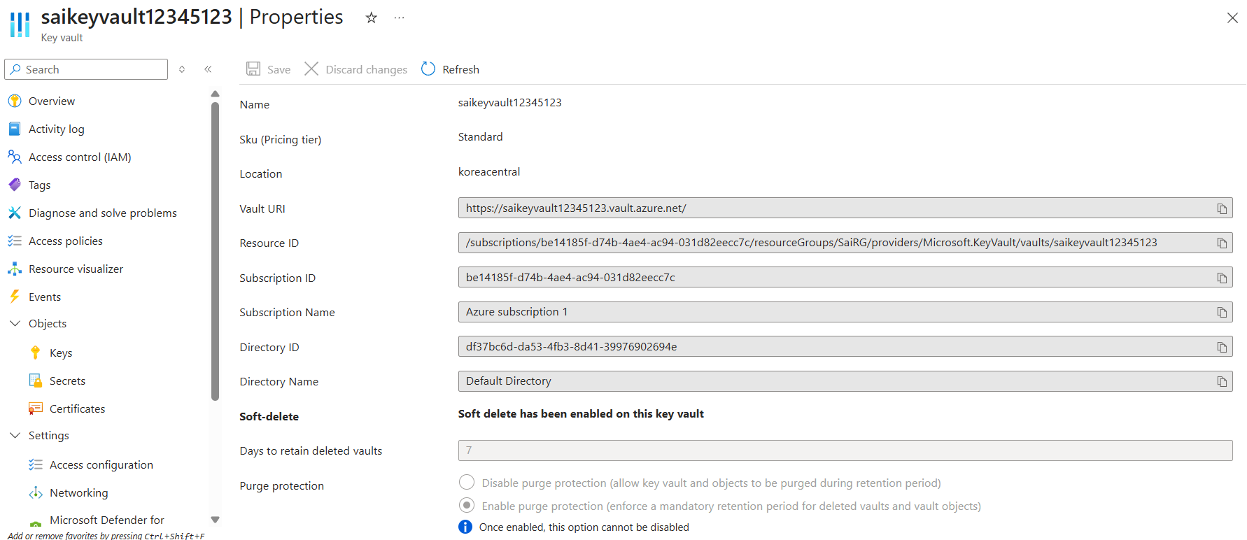

- We can observe as once if we create key vault with enabled purge again we can not disable it as there is no option.

- AZURE KEY VAULT BEST PRACTICES
- Always have backup,
- Turn on ‘Soft Delete’ and ‘Purge Protection’
- When soft delete turned on = soft deleted
i.e not permanently deleted

- When Purge Protection is on = soft deleted key / secret can not be deleted permanently
- If retension period is 90 days then soft deleted key / secret can not be deleted permanently upto 90 days,

- Use RBAC Least Privilege Access
- If any user is created and assigned a role then according to requirement provide only key or secret and with least priviledge
- Provide only Key vault secret / key user, so that user can only read the key
- They can not create or modify the key

- Rotate keys and secrets ( already discussed in 5 )
- If access from public network not needed – restrict access to VNET only

- Azure defender for key vault
- azure defender for key vault detects unusual and potential harmful attempts, to access or exploit key vault accounts,
- This layer of protection helps you address

